**Nam**e: Rowida Mahmoud Ramadan

**B.N**:358

**Topic**: Artificial Intelligence

**Github link**: <https://github.com/Rowida-Mahmoud/ece001>

**Application brief**: the application that I will talk about is the artificial intelligence (AI) I chose this research as it is a really important topic that we should know more about it because AI is a really important technology that we are already using now in many fields and it will be more important in the future

I will talk about some important points that we should know about AI, the first point that we should know is the meaning of AI and when did we start using it, also we will mention its types and technologies and know the meaning of them, we will mention some of its application that helps us in our life, we will also show some statistics related to it.

**Screenshots:**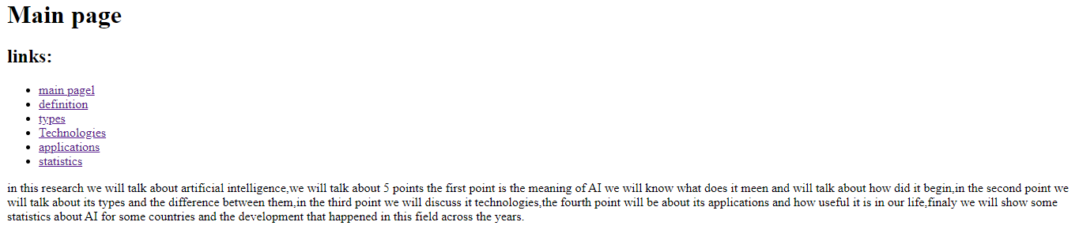

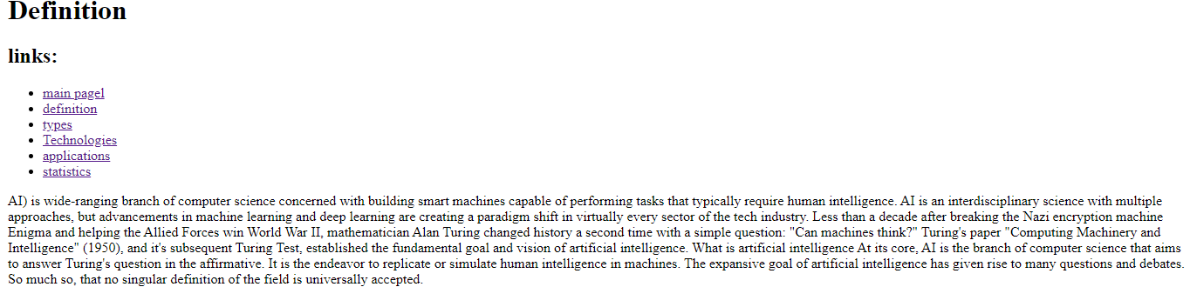

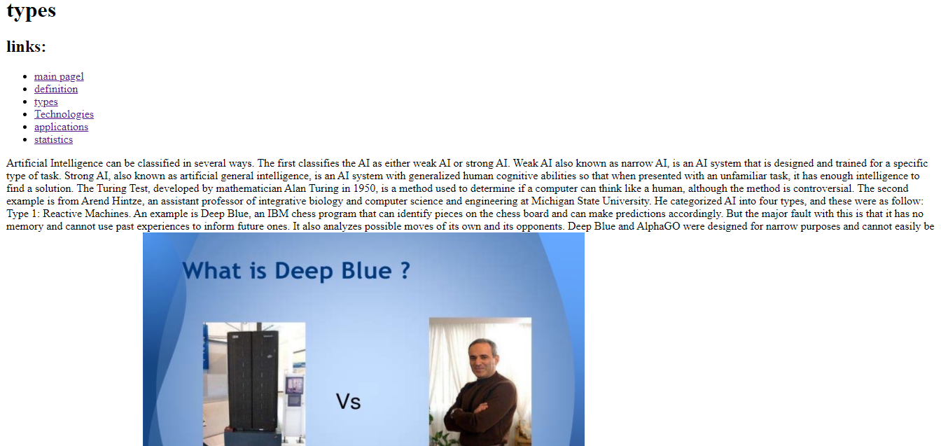

**Source code:**

